JanusMM CAN Driver User Manual

OBJECTIVE:
This document details how to setup hardware and software environment to test the CAN driver.

HARDWARE SETUP:
There are two CAN ports, CANA and CANB, available in the JANUSMM board. These ports are looped-back for testing. The CAN analyzer tapping the CAN packet is also shown in the picture below.

The jumper settings have to be made according to the configuration as mentioned in the Janus-MM Document.

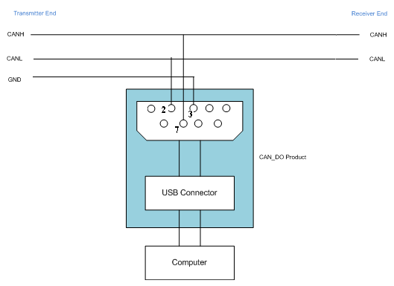

WINDOWS DRIVER SOFTWARE SETUP:
- Driver Installation:
  - Double-click the “install.bat” file to install the driver.
  - Check for the driver entries (CANA & CANB) in “Control Panel -> system -> Hardware -> Device Manager -> Sample Device”.

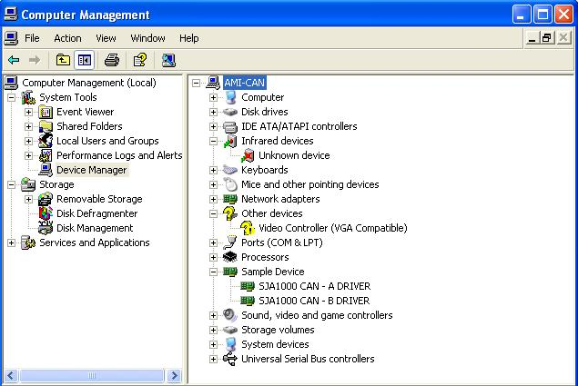

- Driver Un-Installation:
  - Double-click the “remove.bat” file to un-install the driver.
  - Check for the driver removal (CANA & CANB) in “Control Panel -> system -> Hardware -> Device Manager -> Sample Device”.

- Driver Application:
Steps for CAN Frame Transmission & Reception:
- Open two command windows
- Run “canA.exe” in the first command window for transmission.
- Run “canB.exe” in the second command window for reception.
NOTE: The same steps can be followed Vice-versa to make “canA.exe” as master and “canB.exe” as slave.

Command description for canA:
canA <tx> <Loop> <FF> <Identifier> <DLC> <DATA>
<tx> tx = 1; rx = 0
<Loop> Loop Count ( 0 to 0x99 )\n");
<FF> Frame Format ( 0 - SFF ; 1 - EFF )
<Identifier> Identifier Value
<DLC> Data Length should be 8
<DATA> Data
Ex for TX: canA 1 7 0 1 8 1 2 3 4 5 6 7 8
Ex for RX: canA 0

Command description for canB:
canB <tx> <Loop> <FF> <Identifier> <DLC> <DATA>
<tx> tx = 1; rx = 0
<Loop> Loop Count ( 0 to 0x99 )\n");
<FF> Frame Format ( 0 - SFF ; 1 - EFF )
<Identifier> Identifier Value
<DLC> Data Length should be 8
<DATA> Data
Ex for TX: canA 1 7 0 1 8 1 2 3 4 5 6 7 8
Ex for RX: canB 0

- Logging the data transferred:
Example:
TX:
canA 1 7 0 1 8 1 2 3 4 5 6 7 8 > tx.txt
RX:
canB 0 > rx.txt
Both the log files can be compared using any file comparing utility.

LINUX DRIVER SOFTWARE SETUP:
Untar can_beta0.2.tar.bz2 with the following command,
# tar xfvj can_beta0.2.tar.bz2
- Compiling and loading the driver:
From the release directory issue change directory to enter into the driver folder and issue make command,
# cd driver
# make
Run install.sh to load the kernel,
# ./install.sh
Current install.sh is a shell script that uses the following configuration,
canA : Address = 0xD7000 and IRQ = 5
canB : Address = 0xD7200 and IRQ = 7
This can be edited to use different address and IRQ number for both CAN devices.

- Compiling and running the Application:
From the release directory issue change directory to enter into the application folder,
# cd application

Issue the following command. This will create three binaries for transmitting, receiving and setting bitrate.
# ./compile.sh

Run the following command for setting bitrate.
# ./bitrate –h

Usage: ./bitrate [options] [<CAN-Device-Name>]
Options:
-b <bitrate> : bit-rate in bits/sec
-s <samp_pt> : sample-point in one-tenth of a percent
or 0 for CIA recommended sample points
-c <clock> : real CAN system clock in Hz
-h : help
Ex 1: configure bitrate for both canA and canB
# ./bitrate –b 1000000
Ex 2: configure biterate for any one device
# ./bitrate –b 500000 canA

Open two new terminals. And run canrecv and cansend from different terminals.
Canrecv has to be run first. It will wait for data.
# ./canrecv canB

Cansend has to be run next, the command is as shown below.
# ./cansend canA

Help menu for canrecv and cansend is shown below,
  - cansend
# ./cansend –help

Usage: cansend [<can-interface>] [Options] <can-msg>
<can-msg> can consist of up to 8 bytes given as a space separated list
Options:
-i, --identifier=ID CAN Identifier (default = 1)
-r --rtr send remote request
-e --extended send extended frame
-l send message infinite times
--loop=COUNT send message COUNT times
-p --pattern send message data in incremental pattern
-o <filename> Input filename
-v, --version be verbose
-h, --help this help
Ex 1: Transmit CAN frames
# ./cansend canA 0x1 0x2 0x3 0x4 0x5 0x6 0x7 0x8
–l --pattern
Ex 2: Transmit a file continuously
# ./cansend canA –o Transmit.txt

  - canrecv
# ./canrecv –help
Usage: canrecv [<can-interface>] [Options]
Options:
-o <filename> Output filename
-h, --help this help
EX 1: Receive CAN Frames
# ./canrecv canB

EX 2: Receive Files and store the file in incremental order (1recv.txt, recv.txt, 3recv.txt,…….,)
# ./canrecv canB –o recv.txt

Note: For 10 minutes the application can send 37 – 1024 bytes files.

- Stopping the application and unloading:
The application can be stopped by pressing Ctrl+C.
The driver is unloaded using the following command.

# ./uninstall.sh

- Appendix
Example 1:
The delivery package can be tested to transmit data patterns as follows,
- Open a command shell and type the following.
# ./canrecv canB > rx.txt
The application will be waiting for data from ‘cansend’ application.

- Open another command shell and type the following. The ‘cansend’ application will start sending the data.
# ./cansend canA 0x1 0x2 0x3 0x4 0x5 0x6 0x7 > tx.txt

- Leave the applications running for few hours. First stop the ‘cansend’ application by pressing Ctrl-C. Then stop ‘canrecv’.

- Now you have the log files generated at both the ends. And they can be compared using the linux command ‘diff’ as follows,
# diff tx.txt rx.txt

Example 2:
The delivery package can be tested to transmit file as follows,
- Open a command shell and type the following.
# ./canrecv canB -o rx.txt
The application will be waiting for file from ‘cansend’ application.

- Open another command shell and type one of the following command. The ‘cansend’ application will start sending the file.
# ./cansend canA –o tx.txt –-loop=0x5 //will send the file for 5 times
# ./cansend canA –o tx.txt –l //will send the file continuously
# ./cansend canA –o tx.txt //will send the file once

- Leave the applications running for few hours. First stop the ‘cansend’ application by pressing Ctrl-C. Then stop ‘canrecv’.

- Now you have the multiple instances of the transmitted file generated by the receiving node as 1rx.txt, 2rx.txt, 3rx.txt and so on. And they can be compared using the Linux command ‘diff’.

